Development of a Digital Farm Management Portal for implementing Biosecurity measures in Pig and Poultry Farms

Yanamala Jaswanth Reddy
Department of Computer Science and Engineering,
Presidency University Bengaluru, India
jaswanthyanamala@gmail.com

Purohith Satyanarayana
Department of Computer Science and Engineering
Presidency University Bengaluru, India
satyaguru70755@gmail.com

Amaregouda
Department of Computer Science and Engineering
Presidency University Bengaluru, India
amaregouda449@gmail.com

Ms. Poonam
Assistant Professor
School of Computer Science and Engineering
Presidency University Bengaluru, India

Abstract--Pig and poultry farms need biosecurity management to control the transmission of infectious diseases and to help guarantee livestock production is safe. The conventional approaches to farm management practices are mostly based on manual record keeping, which results to low monitoring, lack of consistency in data, and slow reaction to health problems. This paper offers a proposal of a Digital Farm Management Portal to implement the biosecurity measures in pig and poultry farms in order to eliminate these shortfalls. The suggested system is a web-based application that will combine animal health tracking, schedule vaccinations, visitor logs, and sanitation, and feed inventory to one centralized system. The portal offers safe storage of data, automated notifications and generation of reports to enhance supervision and decision making in the farm. The system is developed on the basis of the latest web technologies with scalability architecture to handle many users and big data records. The suggested solution will save the work of manpower, increase accuracy and aid in the high standards of biosecurity within the livestock farms. Farm owners, workers, and veterinarians can effectively use the system to track farm activities and avert disease outbreaks.
Keywords -Biosecurity, Farm Management System, Poultry Farm, Pig farm, Web Portal, Livestock Monitoring, Database System

I. Introduction :
Pig and poultry rearing is a significant factor in food production as well as the agricultural economy. It is necessary to maintain good biosecurity in these farms to avoid spread of infectious diseases and to ensure healthy growth of livestock. Some of the measures in biosecurity entail management of vaccinations, visitor management, supervision of sanitation and appropriate record keeping. Lack of these measures may result in a disease outbreak, loss
of money and decreased productivity. Animal health records, vaccination records, feed records, visitor records, etc. are still kept manually in a register or simple spreadsheet in most farms. These conventional approaches are tedious, prone to error and hard to control as the number of animals grows. It is also not easy to identify the health problem in its early stages due to lack of proper monitoring. As digital technology continues to evolve, farm management systems could be created that will be able to store and track farm data effectively. A digital centralized system assists farmers to keep proper records, biosecurity and create reports readily. Such systems also enhance the decision making as they offer real time information on the activities in the farms. This paper is a proposal of the Digital Farm Management Portal to apply biosecurity measures in the pig and poultry farms. The offered system offers a web-based system that can be used to monitor animal health, schedule vaccination, track visitor logs, ensure sanitation and control inventory in one application. The system will be easy, safe and expandable to ensure that farm owners, workers, and veterinarians can use it.The primary goal of this project is to come up with a trustworthy and convenient digital tool that enhances farm surveillance, a reduced amount of manual labor, and appropriate biosecurity adherence in livestock farms.

II. Literature Review :
1. Kohne et al. (2021) created a livestock farm management system, which is managed on a centralized database, where records of animal health and production are stored, however biosecurity monitoring is not part of the system.
2. Wang and Li (2020) suggested an IoT-based livestock surveillance system to trace the temperatures and movement of animals and enhance the detection of illnesses, but it exposes the costs and complexity of the system.
3. Zhang et al. (2019) revised the review on precision poultry farming methods with the use of automated monitoring, yet the system primarily pays attention to the productivity rather than biosecurity management.
4. Guidelines on biosecurity in animal farms such as sanitation and animal vaccination were offered by FAO (2018), but it is primarily adhered to manually without digital control.
5. The information system presented by Singh and Sharma (2019) based on database technology and aimed at managing farms enhances record keeping but does not include any real-time alerts or security control.
6. Nguyen and Kim (2020) developed a livestock health monitoring system sensor-based and offers real-time information, though it does not assist in visitor tracking and inventory management.
7. The article by Patel and Patel (2019) offered the system of vaccination schedule on the livestock farms, which assist in timely vaccination but lacks full farm management capabilities.
8. Rao and Reddy (2021) created the mobile-based agricultural monitoring system, which only allows limited data entry and does not have appropriate reporting and analytics.
9. Truong et al. (2019) examined the information systems of farm management and discovered that most of the systems are dedicated to record storage and do not facilitate the biosecurity compliance.
10. Zhao and Shen (2020) designed a decision support system on the control of livestock diseases, but the system is too complicated to use with small farms.
11. The WHO (2022) has given the directions on the prevention of zoonotic diseases, which focus on hygiene and vaccination, yet there is no digital platform that would trace the same measures on the farm level.

III. Proposed Methodology :
The Digital Farm Management Portal is designed in different stages to ascertain an appropriate design, implementation, and testing of the system. Each stage is concerned with a particular aspect of development.
Phase 1: Requirement Analysis :
During this stage, the pig and poultry farm requirements are researched. Data on animal health monitoring, vaccination, visitor records, sanitation and stock is gathered. The issues of manual record keeping are outlined.
Phase 2: System Design :
During this stage the general structure of the portal is drawn. It is scheduled to be planned in database structure, user interface, and system modules. Data flow to front end, data flow to back end and data flow to database is defined.
Phase 3: Database Design :
Tables of animals, vaccination, visitors, as well as inventory and users are established in this stage. The database is to be efficient in storing farm data in a secure way.
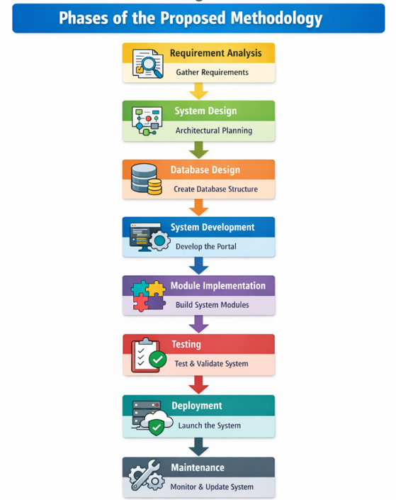
Phase 4: System Development :
At this stage web technologies are used to develop the portal. Frontend is developed to facilitate interaction with the user, backend to perform logic and database to store records.
Phase 5: Implementation of Modules :
Various modules like User Management, Animal Health, Vaccination, Biosecurity Monitoring, Inventory and Reporting are implemented and integrated.
Phase 6: Testing :
The system is put to test to ensure mistakes, accuracy of information and security. Each and every module is checked to make sure it works.
Phase 7: Deployment :
The system is installed in a server in such a way that farm users can use it via the web portal.
Phase 8: Maintenance :
Upon deployment, the system is also monitored and updated when necessary to enhance the performance and introduce new features.
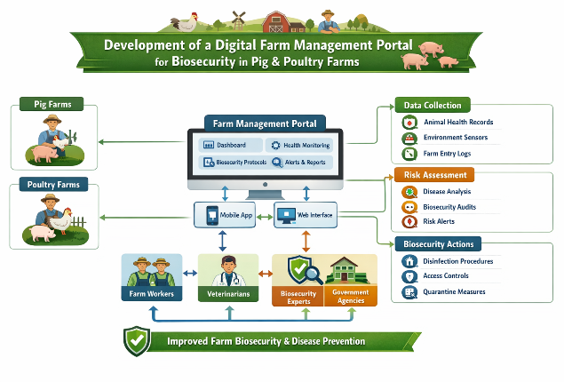
Fig-2

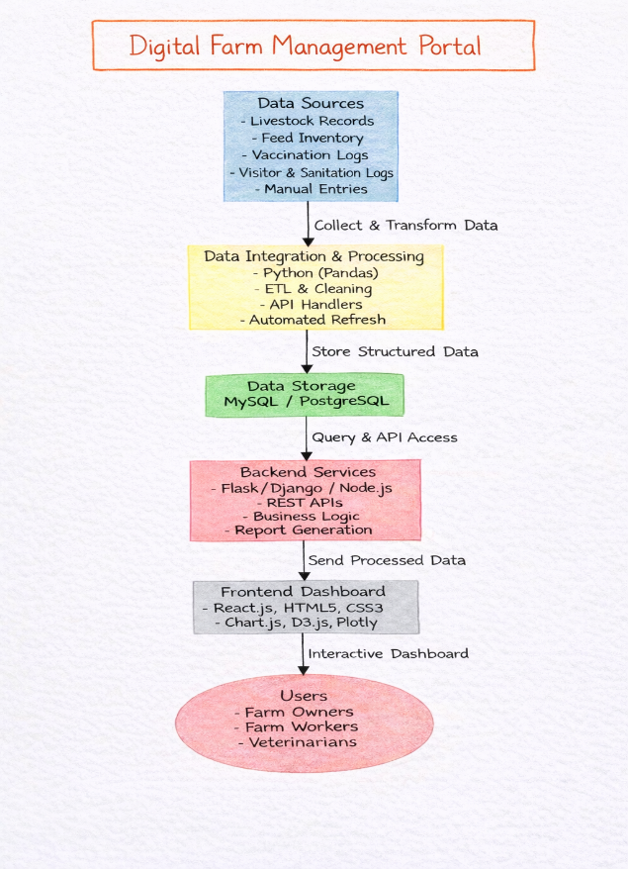
Fig-1(Architecture Diagram)

Fig-3(Dataflow Diagram)

A) Dataset Used :
The data utilized in this study is a farm management records of swine and poultry farms to track the biosecurity level and daily operations of the farm. As the actual farm data is not publicly available, a sample dataset is generated based on the standard livestock management reports, veterinary data, and farm register forms.
The information in the dataset is of various nature that is needed in upholding good biosecurity in farms. These contain animal information, vaccination histories, visitor access records, sanitation history, feed history and mortality records. All the records are typed in a format that allows the system to readily manipulate and retrieve the information.

The key areas covered in the data are:
Type of animal and Animal ID (Pig / Poultry)
Age, Breed, and Weight
Health and Treatment History.
Vaccination Name and Date.
As coming Medicine and Dosage Information. Name of the Visitor, Date, and the Purpose. Sanitation and Cleaning Records
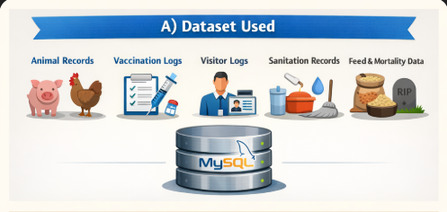
Feed Stock and Consumption Details Feed Stock and Consumption Details Mortality and Disease Reports. The data is stored in a relational database on MySQL and this is apt at enabling efficient storage, updating and retrieval of data. The organized data assists the system to create a report, send alerts on vaccination dates, and have an adequate biosecurity surveillance. Utilizing this dataset allows the Digital Farm Management Portal to trace the activities on the farm to the proper extent and allows farmers to keep the proper hygiene, safety, and disease prevention in pig and poultry farms.
Fig-4(Dataset used)

B) Types of Models Used :
The offered Digital Farm Management Portal is created based on a software architecture model rather than machine learning models. The system is created on the basis of a modular and layered approach in order to provide flexibility, security, and scalability. The system structure is organized with the help of different software models which help to provide the efficient communication between the user interface, application logic and database.
1. Client–Server Model :
The system adheres to the client server model whereby the portal is accessed by the user using a web browser and everything is processed on the server. The client side has the task of putting up the dashboard and accepting the user input, whereas the server accepts the request, gets the data in the database and passes the response back to the user.
The system can be used by various users at the same time since it can be utilized by the farm owners, workers and veterinarians.
2. Relational Database Model :
Farm data is stored in tabular structures of a relational database model. Tables are developed in animals, vaccination record, visitor record, sanitation record, inventory, and user information. All of the tables are related with each other by means of the primary keys and foreign keys in order to establish adequate relations among the data. This model guarantees consistency of data, accuracy and ease of retrieval of records.
3. Three Tier Model of Architecture :
It uses three-tier architecture in designing the system that isolates the system into three layers:
* Presentation Layer- User interface developed with HTML, CSS and JavaScript.
*Application Layer- Backend logic implemented in Java / Flask / Node.js.
* Data Layer- Database based on MySQL and used to store farm records.
This architecture enhances the performance of the system and it makes the application simple to maintain.
4. Modular Software Design :
The portal is separated into self-contained modules which include:
* User Management Module
Animals: Animal Health Management Module.
The Vaccination Management Module is used to vaccinate children and test their blood based on possible diseases.
Epidemiology Surveillance Module.
* Feed & Inventory Module
* Reporting Module
The modules have a particular purpose to perform, and the modules are all interconnected to create the entire system. The system is designed to be easily updated, tested and expanded in the future due to their modular design.
5. Web-Based Application Model :
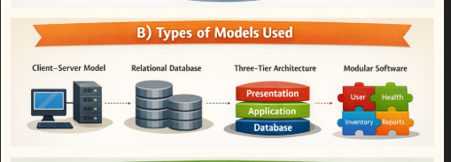
The system is created as a web based application wherein users can access the system through any device as long as they have access to the internet. This model is flexible, can be deployed easily and can support other users without installing the software on each computer. The proposed system is reliable, scalable, and can be used in real-time farm management and biosecurity monitoring because of the application of these models.
Fig-5(Types of models used)

C) Performance Matrices Used :
Various performance measures are applied to the proposed Digital Farm Management Portal to verify the availability of proper performance, efficiency, and security of the system. These performance metrics are used to gauge quality, speed and reliability of the operating system.
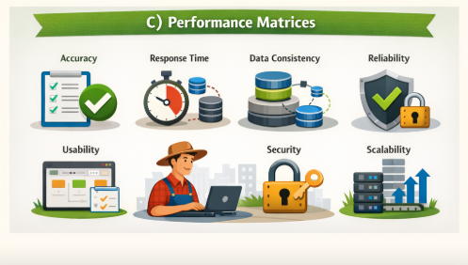
1. Accuracy :
Measure of accuracy is the accuracy of storing and retrieving farm data using the system. The portal checks the user input and then stores the data to prevent one error. Proper animal records, vaccination and inventory data are all properly stored so that the activities in the farms are monitored accurately.
2. Response Time :
Response time is the time response to a request by the user. This involves loading the dashboard, retrieving records as well as producing reports. This system will be configured to give quick response to avoid any delays in accessing information by the users of the farm.
3. Data Consistency :
Data consistency is used to ensure that the information in the database is accurate and consistent. The same database is used in all the modules, eliminating duplication and wrong information. This assists in keeping sound farm records.
4. Reliability :
Reliability is a measure of stability of the system when in constant use. The portal must be crash free and should not lose data even when it is used by multiple users. They are regularly tested to make sure that they perform smoothly.
5. Usability :
Usability examines the ease of use of the system by the farm owners, workers and the veterinarians. Its interface is intended to be easy to use and understand. Adding records, seeing reports, and updating information are easy to the user.
6. Security :
Security should guarantee that the system is only accessed by authorized persons. Farm data is secured by means of login authentication and role-based access control. This helps to avoid illegal modifications of significant records.
7. Scalability :
Scalability is the capacity of the system to stand more farms, animals and users in future. The modular nature enables the additions of new features to the system without altering the current system. This renders the portal to be applicable to small and large farms.
Fig-6(Performance Matrices)
IV. Results and Discussion :
The Digital Farm Management Portal was developed and tested successfully to test its effectiveness in managing the farm data and applying the biosecurity in the pig and poultry farms. Sample datasets, which consist of animal health records, vaccination schedules, visitor logs, sanitation data and inventory details, were used to test the system.
The findings indicate that the system can store, process and recall farm data without any errors. All the modules like Animal Health Management, Vaccination Scheduling, Biosecurity Monitoring and Inventory Management are operational and integrated. The system will give a centralized place whereby all the activities that concern the farm can be tracked in an efficient manner.
The system is found to be fast in the response time and reports and dashboards are loaded quickly. The users are able to have a real time access to information including status of vaccination, feed stock and visitors. The automatic alert system is effective in alerting users when vaccinations are due and when the supply is limited because it assists in managing the farms.
The system also provides consistency of the data as the records are well organized to have a structured database. This will minimize redundancy and mistakes during the entry of data. Reliability testing demonstrates that the system is a smooth operating system even in the case of many users at the same time.
The portal is user-friendly and easy to navigate, as far as usability is concerned. The owners of the farm, workers, and veterinarians will be able to use the system fast without the need of technical skills. The dashboard is user-friendly, allowing one to see the farm information in the form of reports and summaries.
Such security measures as the use of login authentication and role-based access control guarantees that the data may be accessed by its authorized users only. This helps in securing important information on farms against unauthorized access.
On the whole, the findings reveal that the suggested system contributes greatly to the effective management of farms due to the decreased amount of manual labor, enhanced precision, and the appropriate application of biosecurity practices. The system assists in the early identification of possible problems, enhanced design of activities in the farm, and eradication of disease outbreaks.
The solution has been proposed to the small and large-scale pig and poultry farms and can be even advanced with additional features like mobile access and real-time monitoring.
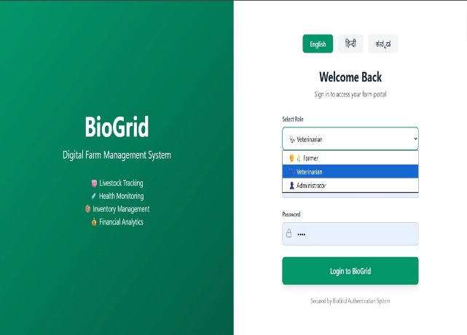
Fig-7(Register & Login Page)
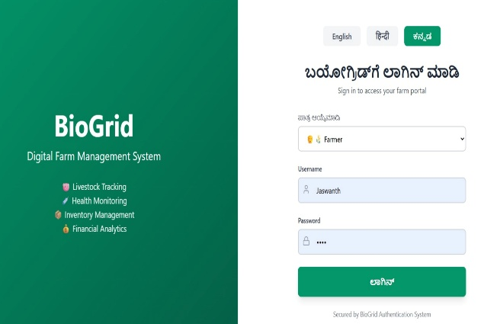
Fig-7-I(Login page in Preferred Language-(Kannada))
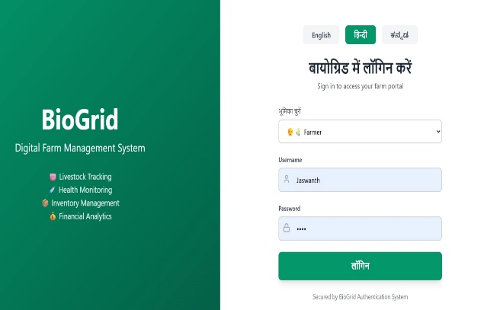
Fig-7-II(login page in Preferred Language-(Hindi))
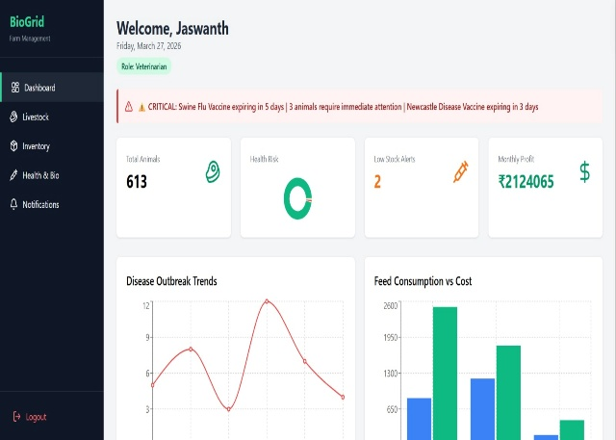

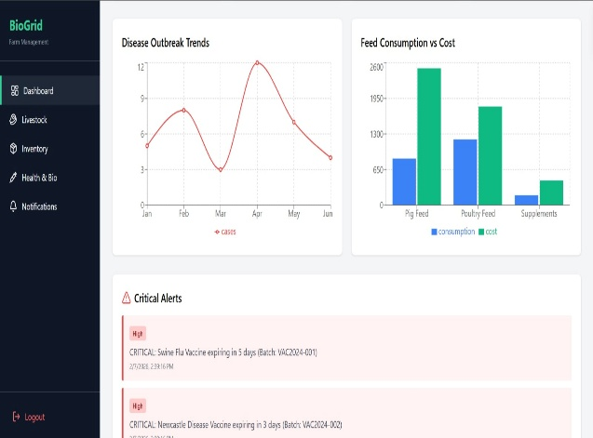
Fig-8(Dashboard)
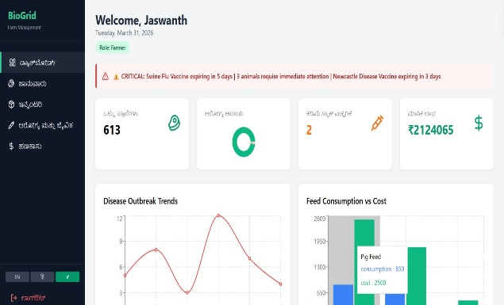
Fig-8-I(Dashboard in Kannada)
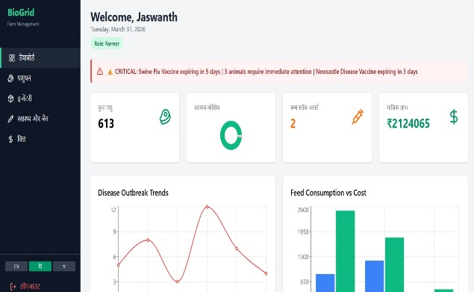
Fig-8-II(Dashboard in Hindi)
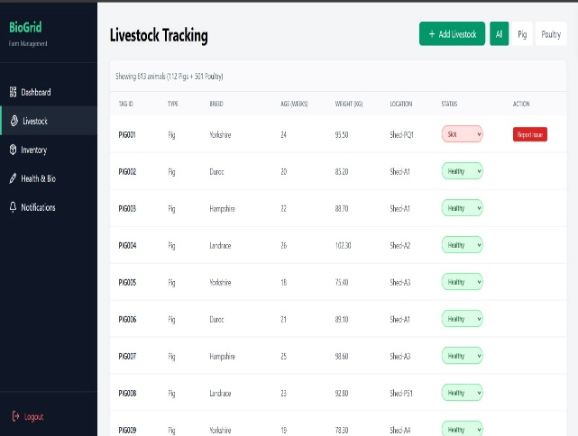
Fig-9(I)(Livestock Tracking)
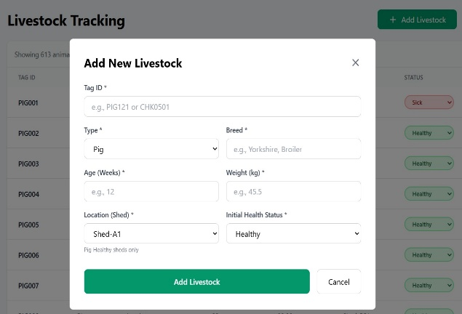
Fig-9-II(To add new stocks)
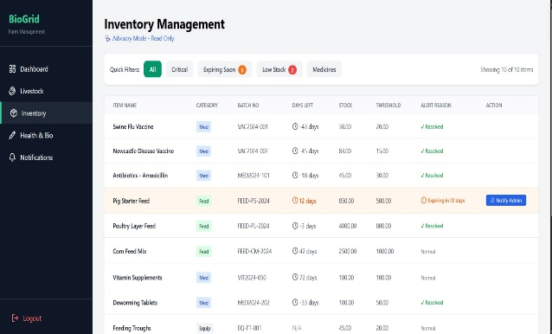
Fig-10-I(Inventory Management)
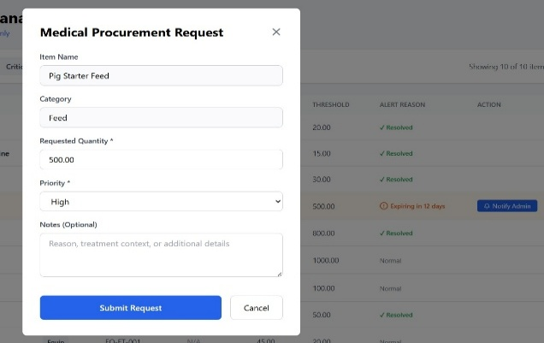
Fig-10-II(Medical Request)
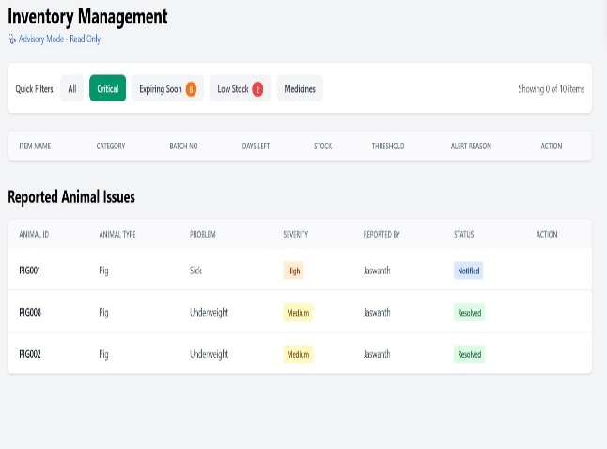
Fig-10-III-(Critical Field)
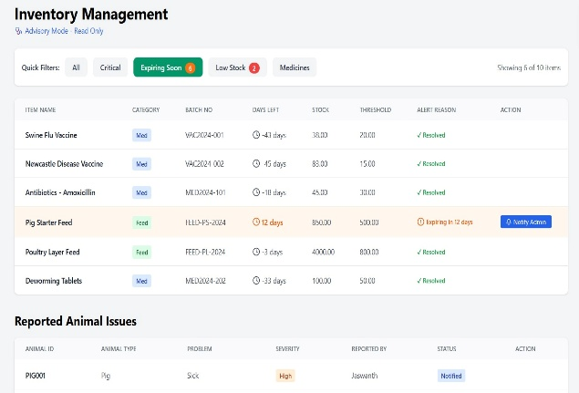
Fig-10-IV(Expiring Field)
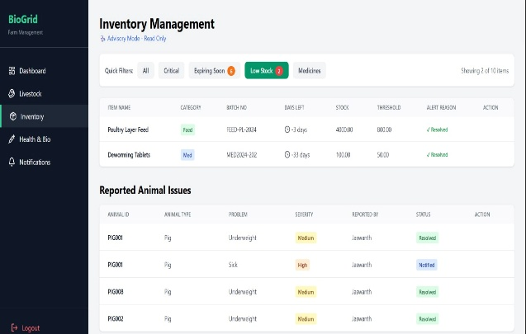
Fig-10-V(Low stock Field)
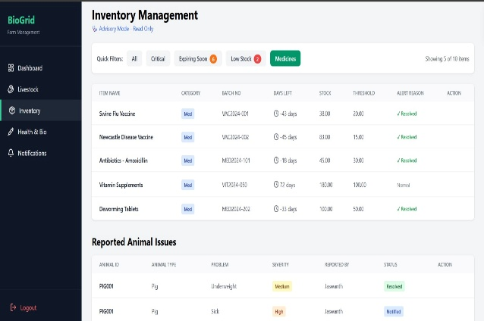
Fig-10-VI(Medicine Field)
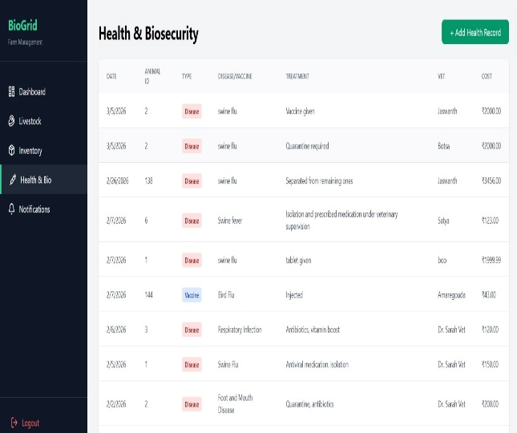
Fig-11(Health & Biosecurity)
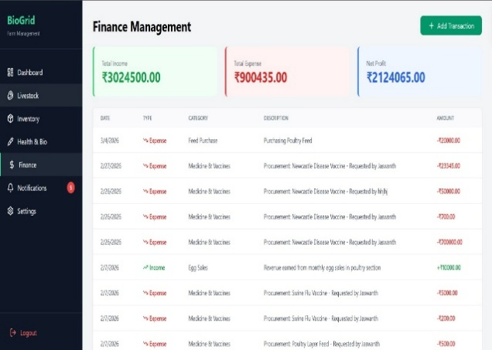
Fig-12(Finance Management)
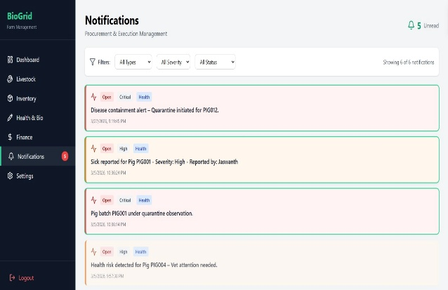
Fig-13(Notifications)
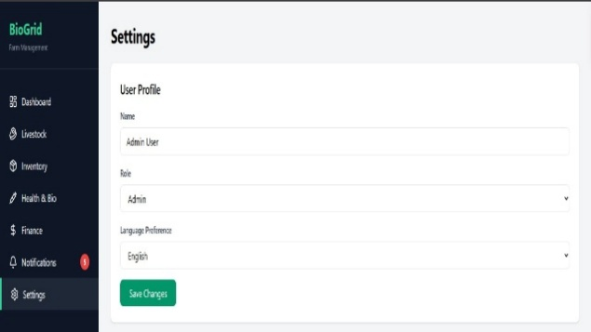
Fig-14(Settings)

V. Conclusion :
The proposed and developed Digital Farm Management Portal about biosecurity measures in pig and poultry farm implementation is offered in this paper. The system will substitute the old manual record keeping system with the centralized digital system that can aid in the management of animal health records, vaccinations schedules, visitor logs, sanitary activities, and inventory. Farm management is also more accurate, efficient, and reliable when a web-based portal is used.
The built system has an easy and convenient interface, which enables the owners of farms, workers, and veterinarians to keep a check on the farm activities with ease. The system of automatic vaccination and inventory notifications will assist in avoiding disease outbreaks and ensuring adequate standards of biosecurity. The structured database also guarantees secure storage and easy access to farm data.
System performance analysis reveals that it offers quick response, clean and correct data handling and secure access by authentication and role control. The portal is constructed in a modular manner; hence, it is simple to maintain and use in the future. The system is able to handle various farms and massive data without performance degradation.
Altogether, the proposed Digital Farm Management Portal is a suitable solution in enhancing biosecurity data and pig and poultry farm management. The system can be further improved with mobile access, cloud storage, and advanced data analysis capabilities to boost the productivity and prevent diseases in the farm in the future.

VI. References :
[1] FAO, Animals in Biosecurity, Biosecurity in Animal Production and Veterinary Public Health, 2018.
[2] World Health Organization, *Guidelines to prevent Zoonotic Diseases-set 2020, WHO Press, 2022.
[3] A. Kohne, M. Ebert and J. Schulz, Design of a Livestock Farm Management Information System, IEEE Access, vol. 9, 11234-11245, 2021.
[4] L. Wang and X. Li, “Smart Livestock Monitoring IoT and Cloud Computing based solution Sensors, vol. 20, no. 15, pp. 115, 2020.
[5] F. Zhang, M. Hasan, Precision Poultry Farming: A Review, Computers and Electronics in Agriculture, vol. 162, pp. 731 742, 2019.
[6] T. Nguyen and H. Kim, Wearable Sensor-Based Livestock Monitoring System, Internet of Things Journal, vol. 7, no. 5, pp. 4321-4330, 2020.
[7] R. Singh and S. Sharma, Farm ERP: Integrated Information System to Livestock Farms, International Journal of Agricultural Management, vol. 8, no. 2, pp. 4552, 2019.
[8] P. Kumar and A. Gupta, Machine Learning Based Disease Detection in Poultry Farms, Elsevier Computers in Agriculture, vol. 175, pp. 105 115, 2021.
[9] H. Al-Amin, M. Rahman, Cloud-Based Farm Management System Architecture, Journal of Network and Computer Applications, vol. 189, pp. 103112, 2022.
[10] B. Patel and R. Patel, Vaccination Scheduling System for Livestock Farms International Journal of Biological Engineering, vol. 6, no. 3, pp. 8895, 2019.
[11] S. Rao and P. Reddy, Mobile-Based Farm Monitoring System, Journal of Mobile Computing Applications, vol. 10, no. 1, pp. 21 30, 2021.
[12] M. Islam, K. Hossain, Database Design of Livestock Management Systems, ACM Transactions on Database Systems, vol. 43, no.4, 1-12, 2018.
[13] L. Truong, D. Nguyen, Farm Management Information Systems: Adoption and Challenges, Journal of Rural Studies, vol. 65, pp. 100110, 2019.
[14] C. Zhao and Y. Shen, Decision Support System on Livestock Disease Control, Expert Systems with Applications, vol. 150, pp. 113120, 2020.
[15] P. Singh, R. Verma, Biosecurity Practices in Poultry Production Preventive Veterinary Medicine, vol. 190, pp. 105112, 2021.
[16] G. Johnson and T. Clark, Architecture of Scalable agricultural data systems, IEEE Transactions on Cloud Computing, vol. 10, no. 2, pp. 567578, 2022.
[17] K. Brown, L. Davis, “Impact of Digital Tools in Smallholder Farming," Agricultural Systems, vol. 177, pp. 102110, 2020.
[18] J. Lee and D. Kim, Web-Based Information System to Livestock Farms, International Journal of Web Engineering, vol. 14, no. 3, 2018, pp. 201210.
[19] R. Dasgupta and S. Pal, Review of Smart Farming and Animal Tracking Systems Computers in Agriculture and Food Research, vol. 4, pp. 100110, 2021.
[20] S. L. Ge, W. Wolfert, C. Verdouw and M. J. Bogaardt, Big Data in Smart Farming: A Review, Agricultural Systems, vol. 153, pp. 6980, 2017.

